**Employee Database Analysis**

# Overview

The purpose of this analysis is to determine the number of retiring employees per title and identify the employees who are eligible to participate in the mentorship program. The data about retiring employees provides insight about the titles of employees born between 1952 and 1955. The data’s goal is to help prepare management for the high amount of employees retiring by guiding the transition through a strategic mentorship program to address the skills, knowledge and leadership gaps.

# Results

* 83% of retiring employees are senior staff and senior engineers.
* Only 1549 of employees are eligible for mentoring the next generation of senior engineers and senior staff.

* 30% of total employees are eligible for retirement (90,398 out of 300,024).
* Development, Production and Sales departments have the highest number of retirees.

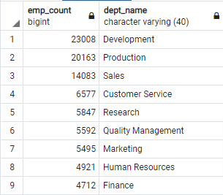

# Summary

* An estimated 90k employee roles will need to be filled as the silver tsunami begins to make an impact.
* There are 1549 qualified retirement ready employees available to mentor the next generation of employees.
* This is of major concern. The low amount of employees eligible for mentorship compared to the 90k gap is a serious cause for concern.
* Leadership will need to consider options for streamlining operations to assist in decreasing the impact of this loss of skills, knowledge, and experience.